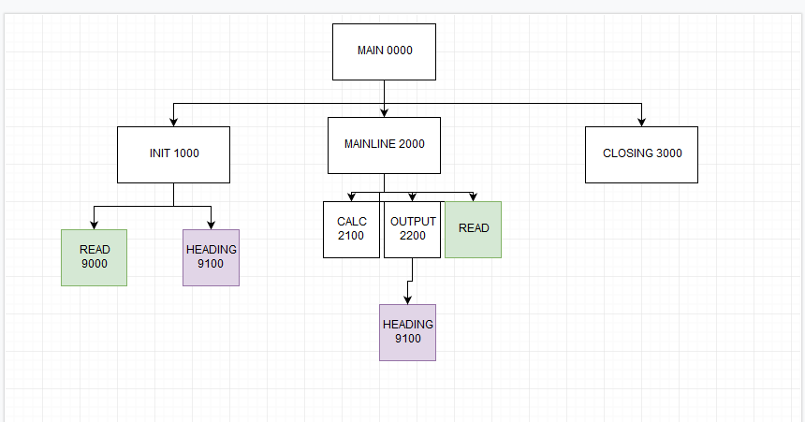

Variable definitions

AlphaNumaric - I-REC, I-ID, I-LNAME, I-NAME, I-FNAME, I-INIT, O-DATE, O-PCTR,O-GPA, O-START-SALARY, O-ID, O-LNAME, O-FNAME, O-SCTR, EOF = "TRUE"

Numaric I-GPA, I-START-SALARY, I-DATE, C-SCTR=0, C-PCTR=0

MAIN

CALL INIT

WHILE EOF="TRUE"

CALL MAINLINE

CALL CLOSING

MAINLINE

CALL CALC

CALL OUTPUT

CALL READ

CLOSING

PRINT BLANK LINE

O-SCTR = C-SCTR

PRINT TOTAL LINE

CLOSE INPUT FILE

CLOSE OUTPUT FILE

CALC

C-SCTR +=1

OUTPUT

O-ID = I-ID

O-LNAME = I-LNAME

O-FNAME = I-FNAME

O-GPA = I-GPA

O-START-SALARY = I--START-SALARY

PRINT DETAIL LINE

PRINT BLANK LINE

IF END OF PAGE

CALL HEADING

INIT

OPEN INPUT FILE

OPEN OUTPUT FILE

REQUEST SYSTEM DATE

GET I-DATE

O-DATE = I-DATE

CALL READ

CALL HDGS

READ

READ RECORD, I-REC, I-ID, I-NAME, I-LNAME, I-FNAME, I-INIT, I-GPA, I-START-SALARY

IF END OF FILE

EOF = "NO"

HDGS

C-PCTR +=1

O-PCTR = C-PCTR

PRINT TITLE LINE

PRINT BLANK LINE

PRINT COLUMN HEADING LINE 1

PRINT COLUMN HEADING LINE 2

PRINT BLANK LINE